SECTION 2 - INVESTIGATION
INTRODUCTION:
In this section, I will investigate El Aziz’s systems efficiency. While the restaurant currently uses a manual system for taking orders and managing tables, issues are still present. Through my research. Therefore, I intend to produce a sophisticated and detailed investigation to identify issues with their current system to ensure that I can prepare effective solutions for the problems. My proposed system aims to address these common problems while meeting the specific needs of the client’s restaurant. I will carry out my research by firstly, investigating the system. I will do this by sending out a survey to customers/clients that have been to El Aziz and ask them about their experience adjusting to their manual system which is prone to error. I will then arrange an interview with the restaurant owner to learn more about his experience with the current system and identify his needs for my new system to be developed. Finally, I intend to visit El Aziz and experience their customer service, first hand. I will then write up my findings to consolidate what I observed. After I have completed this, I will proceed to perform secondary research by searching online for 3 similar systems to my new system idea. This will allow me to review and list features in these existing systems and compare them to my own concept. I will evaluate these systems to consider which features I like and how this research has influenced my decision making. Moving forward, I will identify stakeholders and users and describe how they currently interact with the system, while explaining the current inputs and outputs they deal with. Finally, I will produce a series of data flow diagrams to express the current systems inputs, processes and outputs allowing me to identify the new requirements for my new concept.
INVESTIGATING THE CURRENT SYSTEM:

CUSTOMER SATISFACTION SURVEY:
I produced a survey asking customers and clients that have been to El Aziz to share their experience with the system. Here are my results:
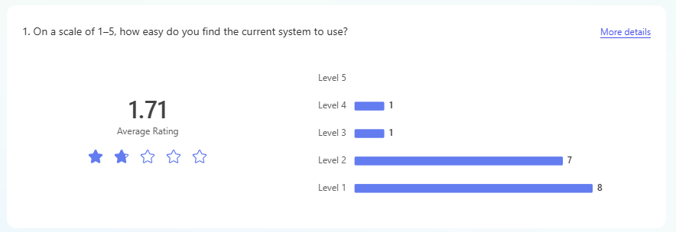Question one asked about the functionality of the system, questioning its efficiency and easiness to use and navigate. This question was a rating question between 1 and 5, 1 for being difficult and 5 for being easy. The average rating for this question was 2 which is concerning. This question demonstrates that their current manual system is inefficient and confusing for customers. Due to handling paper bookings, and storing data and orders on pen and paper, it can be very easy to misplace or lose this data, slowing down the process of creating bookings/orders and can cause confusion and stress for both the workers and customers.
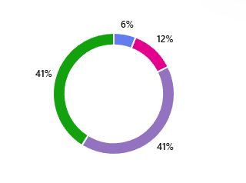
Moving on, question two asked regarding how easy it is to customise and edit customer orders by adding or deleting items and specialising in items. The result for this question was that most customers found it between somewhat and extremely not easy. Overall, 82% of the survey takers expressed that they found this process difficult. Therefore, the results tell me that customers at El Aziz were finding it difficult to customise and edit their orders which is possibly because they are a non-digital system, so they use manual bookings and order taking through pen and paper. Due to their being a limited number of staff and considering if they visited during busy hours, being able to reach the staff and ask to individually retrace their order and change their order by removing or adding an item may have not been possible. However, if the restaurant had an online system, customers wouldn't have to rely on staff to edit their order, they would be able to go onto the platform and find their order and edit it quickly. Remembering my feedback from my discussion, it is important to consider the restaurants policy on editing orders and if there is a certain time they can no longer change it. This is to reduce waste and prevent confusion.
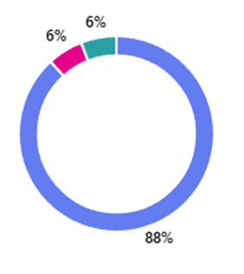
Moreover, question 3 asked if customers have ever encountered problems with items being “available” on the system but not in stock. Unfortunately, 88% of the survey takers have experienced this issue. This tells me that the manual system is not up to date with their stock income. Communication and awareness seem to be an issue here as workers and admin have misinformed customers and clients of available items when they aren't present in the restaurant stock. Incidents like this can upset customers as its misinformation and can cause negative feedback and customer experience which could be damaging for the restaurant's reputation and revenue.
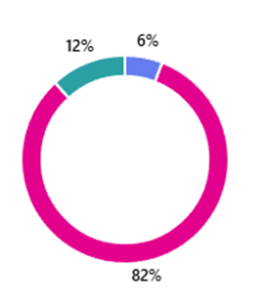
Furthermore, question 4 was regarding the systems connection with payment machines. As El Aziz is in a village, there are limited payment options with just cash and physical money only being accepted. No card readers and contactless payment is accepted due to the lack of infrastructure. This led to the 82% of the survey takers answering “No” to this. The lack of payment options reduces inclusivity and limit its functionality by only appealing to customers who will pay with cash. This is inconvenient for customers who do not have cash on them and therefore need to find an ATM machine to take cash out to pay.
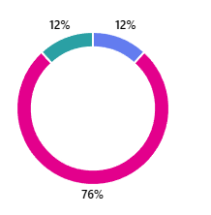
Question 5 questioned the system's ability to generate useful reports to which 76% of clients said no. This demonstrates how El Aziz fails to provide valuable insights that will help run their business better. Without reports, it’s hard to track important things like which dishes are most popular or staff performance. This means decisions are based on guesswork instead of real data, which can lead to missed opportunities, wasted resources, or inefficiencies. Reports can also help identify problems early on and plan for growth, so not having those limits the restaurant’s ability to improve and compete. This inability to generate reports is mainly due to data being stored manually which is difficult to locate and easy to lose.

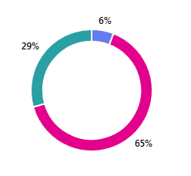
Moving forward, question 6 asked “Do you feel customer data is handled securely by the system?” and results show that 65% said no, 29% said yes and 6% said maybe. From this, I concluded that most customers were concerned about data security which is possibly since it is all taken down on paper with no back up method, highlighting the risk of data loss.
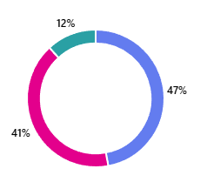
Next, question 7 asked “Have you experienced billing errors caused by the system?” to which 47% claimed they did while 41% claimed they didn't. This tells me that their manual system is inaccurate with calculations which is causing confusion and misinformation which is leading to people being charged too little or too much.

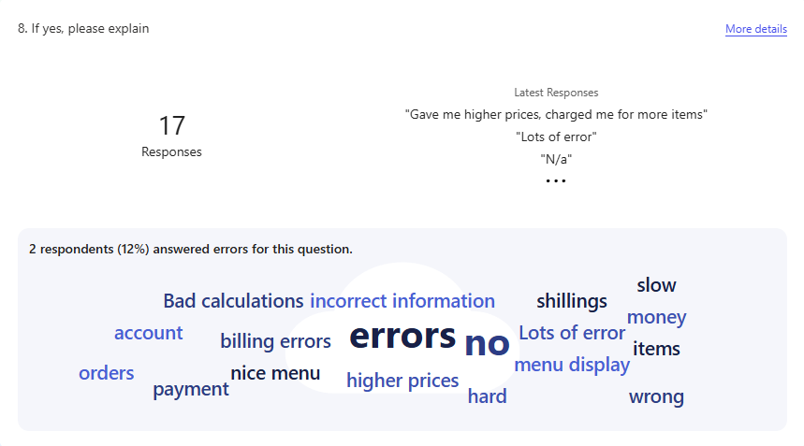
In question 8, I asked them to explain the situation they encountered. Responses explained that they had inaccurate calculations on the till which led to the overcharging of prices. Also, people were instructed to pay twice because the staff weren't keeping records of who paid and who hadn't which caused confusion. This tells me the organisation of data and tracking order stages is a big issue at El Aziz and must be solved.
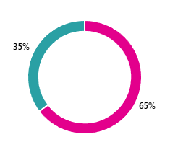
Furthermore, question 9 questioned the system's ability to handle table bookings effectively to which 65% of responders selected no. Surprisingly, 0 customers said yes and 35% said maybe. This demonstrates the customer’s dissatisfaction with table bookings. The systems inability in handling table booking effectively is concerning as a typical restaurant system should be able to reserve and allocate tables for guests. As this is a paper-based system, preserving data may be difficult as it is easy to lose.
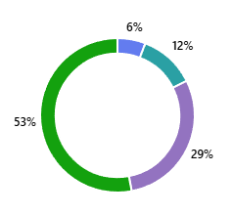
Finally, question 10 asked "How satisfied are you overall with the current system?”. 53% responded with ‘very dissatisfied’ and 29% said somewhat dissatisfied. Ultimately customers aren't happy with the current manual system due to concerns with data loss, security and organisation. This demonstrates that El Aziz’s current system isn't as functional and efficient, and customers would like it to be.

To conclude, from this survey research I have discovered that customers are not satisfied with El Aziz’s current manual paper-based system as it is difficult to navigate and raises multiple concerns regarding data such as security, loss and organisation. I intend to solve these issues and reduce concerns with the system to develop a digital system that will be able to handle table bookings effectively, produce reports and offer easy customisation of orders.

INTERVIEW:
To deepen my research and understand the current manual system further, I arranged and performed an interview with the restaurant owner of El Aziz, Sherzod Karimov. Here is what he said:
QUESTION: “Can you describe your current table booking system works?”
ANSWER: “Right now, our table booking system is completely paper based. We use a notebook kept near the counter where staff write down reservations by hand. When a customer calls or visits to book a table, we write down their name, phone number, number of people, date, and time. We just flip through the pages to check availability. During busy periods, this can get confusing because there’s no easy way to see overlaps or double bookings unless you go through everything manually. Mistakes happen sometimes, especially if different staff are on shift and don’t communicate properly.”
QUESTION: “How do you currently take and manage customer orders?”
ANSWER: “We also handle customer orders using a paper-based system. When customers place their orders, either in person or over the phone, the waiter writes everything down on a paper pad. The order slip is then taken to the kitchen where the chefs read it and prepare the food. Because it is just handwritten notes, sometimes orders get lost, or misunderstood if the handwriting isn't clear. For custom requests (e.g “extra spicy”), the staff write them manually, but these can be missed easily, especially during busy hours. If a customer asks about the status of their food, the staff must go and check manually with the kitchen.”
QUESTION: “Have you ever encountered issues with missing or incorrect orders, if so, do you think it's due to having a paper-based system?”
ANSWER: “Yes, definitely. We’ve had quite a few issues with missing or incorrect orders over the years, and I’d say the paper-based system is a big part of the problem. Sometimes the handwriting is unclear, or an order slip gets misplaced on the way to the kitchen. Other times, customisations like "no onions" or "extra sauce" are accidentally skipped because the note wasn't seen or was written in a hurry. During busy times, it becomes even more chaotic. Mistakes are more frequent, and there’s no reliable way to track or double-check what was actually ordered unless someone remembers it. A digital system would really help reduce these kinds of errors.”
QUESTION: “Are there any other issues that your system faces, if so, what would you say is the biggest and most prominent problem?”
ANSWER: “The biggest problem is data organisation and security. Since everything is written down on paper, it's very easy to lose information, whether it’s a booking, an order, or customer contact details. Pages can get damaged or go missing. We've had cases where a customer’s reservation couldn’t be found because the page was accidentally removed or written on the wrong day. Another problem is data security. All our customer information like phone numbers, names, and special requests is just sitting in notebooks that anyone can open. There’s no way to protect it or limit who has access. Our system is very inconvenient. Flipping through pages to find information takes time, there’s no backup if something is lost, and it’s hard to keep things organised, especially when the restaurant is busy.”
QUESTION: “How do you currently protect customer and business information?”
ANSWER: “Right now, we don’t have any formal way to protect customer or business information since everything is on paper. The notebooks are kept behind the counter where only staff have access, but there’s no password or security, anyone who comes behind the counter can see the information. This makes me worried about privacy and data security, especially with sensitive customer details like phone numbers. It’s one of the reasons why I want a more secure digital system that can protect this information better.”
QUESTION: “What features would you like in a new digital system?”
ANSWER: “I’d like the new system to have easy table booking management, order customisation options so special requests are clearly communicated to the kitchen, and a secure customer database to store contact details and booking history for better service. It'd be nice to have an interactive and efficient system with pictures and our logo. ”
QUESTION: “How comfortable is your staff with using digital systems or technology in general and would you be open to training your staff to use a new digital system?”
ANSWER: “Most of my staff have limited experience with digital systems. Some are comfortable using smartphones and basic apps, but many aren’t used to more complex software. However, I’m definitely open to providing training so everyone can learn how to use the new digital system properly. I believe with the right support, they can adapt quickly, especially if the system is user-friendly and designed with their needs in mind.”
From this interview with Sherzod Karimov, owner of El Aziz, I have learnt that he recognises the current issues with his manual system which is paper based. His responses align with the customer and clients that took part in my survey which demonstrates how the issues are major and prominent across everyone involved with El Aziz. Problems with the system mainly revolve around data and security which is something I will solve and implement in my new digital system to combat the problems.
OBSERVATION:
To understand El Aziz’s current manual paper-based system I went to visit and observe the restaurant myself. This was so that I could really see the true and prominent issues with their system to ensure my solution is effective and efficient, improving El Aziz’s restaurant system.
During my visit, I observed that the table booking system relies entirely on a handwritten notebook. Staff had to manually flip through pages to check availability, which caused some confusion when two bookings overlapped. This made it difficult to manage reservations efficiently, especially during busy hour. Also, waiters took orders using paper pads, which occasionally led to illegible notes and occasional misunderstandings with the kitchen staff. I noticed one order slips pen was smudged, making it hard to read a customer’s special request on their order, which could lead to errors. Because of this, there was a delay in the customer's order and upset the customer due to longer waiting times. Staff and waiters would check the order status whenever a customer asked them about their food which is very inefficient and unprofessional as it shows disorganisation. The staff would reassure the customer that they would check on their food and walk to the kitchen, questioning the chefs on their order and then inform the customer of their waiting time. Some staff and waiters would estimate a waiting time for the customer instead of checking. Due to the inability of real time order status tracking, it was more difficult to update their customer on their food and caused confusion which is damaging to their experience and El Aziz’s reputation.
At times when the restaurant was busy, the waiters and staff seemed quite overwhelmed with the volume of orders and their performance was affected by this. At lunch time, more customers and families would walk through the door asking for a table or karavat as they hadn't phoned the restaurant in advance reserving a table. I saw the waiters frantically flicking through pages trying to see if a table was already reserved or not and if there was any double bookings or availability. I witnessed customers get upset after a family found out that their table they had reserved and booked in advance was being used by another family because there had been a double booking. New customers would come rushing to the chef that grilled outside and tell the waiter next to him their order as he quickly wrote it down. Due to loud commotion of construction nearby, I could tell he hadn't fully understood what the customer had said which could have led to an incorrect order. As I had visited during the summer, the busiest time was the evening as the weather was a lot cooler, so more people were outside. This led to waiters simultaneously taking orders, staff running and rushing around staff flicking through more pages. This particular evening there had been a lot of delays in customer’s meals which led to a lot of pressure and stress on the workers. They kept reassuring the customers that their food would be ready in 5-10 minutes but because orders kept flooding in on paper and writing was inadmissible, the chef were unable to complete the order.
From what I saw, all customer data and information is written in a separate notebook to the orders and is just kept behind the counter at the front. When workers needed to find a table reservation, they asked the front desk and located it from there. Due to the notebook writing “customer information” at the front in bold and being sat on the top of the counter at the entrance, I was concerned about safety and security as anyone could've easily taken it. The front desk also had tea on the counter which could have spilled onto the book damaging the book and potentially risking the loss of data. Luckily, I didn't witness any damage to the notebook and customer data.
Overall, it is quite difficult for staff to find information and be update quickly as the workers don't have the same access to different data and must go to the people who handle it. As previously explained, there were many encounters that demonstrated the disorganisation of the system as I witnessed double bookings and incorrect orders occur. I would say that the staff spend more time flicking through their notebooks and managing the paperwork than serving the customers which is negatively impacting their performance and reputation. Due to the lack of efficiency with order taking on notes, at times I saw that staff were relying on their memory instead of even bothering to write it down because they were confused as shown through their expressions. There seemed to be a lot of frustration when manging the paperwork as it was time consuming and stressful.
SECONDARY RESEARCH:
To gain more insight as to what I would like my system to do, I researched 3 existing restaurant systems that feature all the aims of my project. I decided to research McDonalds and Saray Restaurant to investigate their digital systems and observe what unique features they have that I would like to embed into El Aziz’s system. I considered the systems: aesthetics, efficiency and functionality through observing the platforms on different devices. I did this as most customers would arrive at the restaurant with a mobile phone, meaning my system must be able to function and display correctly on mobile phones to ensure customers can use it easily. Moreover, I then research restaurant management software such as ‘toast’, and I wanted to investigate how the website presents reports and analytics and how I could incorporate this into El Aziz’s system.
Here are the systems I researched:
McDonald’s UK
Saray – Turkish Cuisine
Restaurant Reporting & Analytics | Toast POS

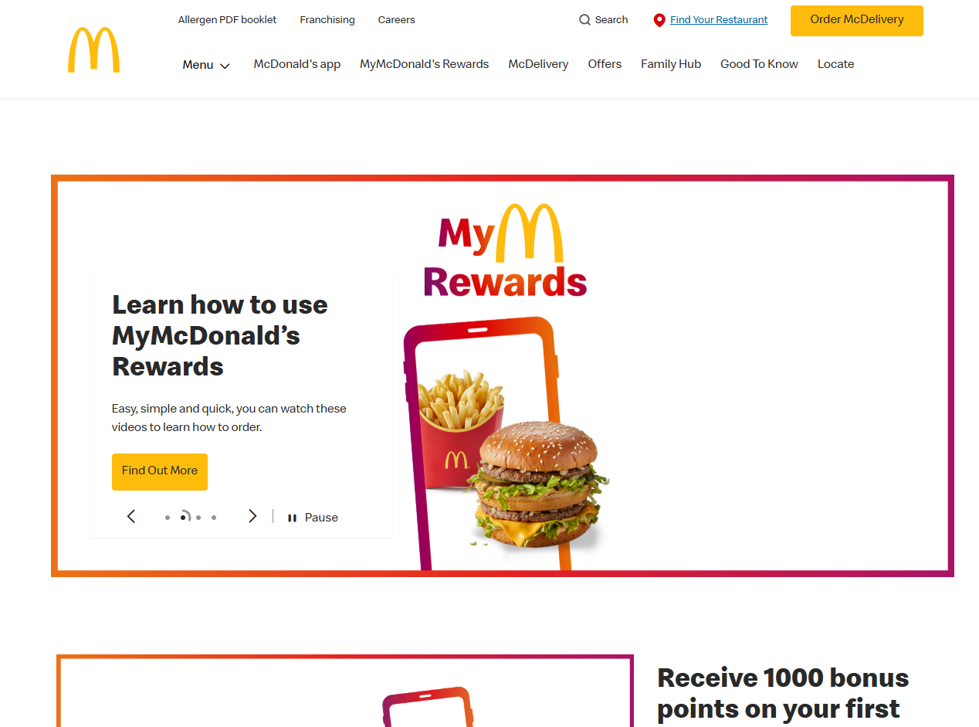
McDonalds:
Firstly, I looked at McDonalds’ system on a computer/laptop. At first glance, the platform is easy to navigate due to it having meaningful icons, images of food and colourful buttons that stand out to users. This UX design is efficient as it considers bright colours and simple white background to make the interface clear and easy to understand and use. It is accessible and accommodates all customers through its bright colours to enhance readability but also to represent their brand. However, when I loaded the website on my mobile phone, it was a lot smaller, images were cut off but it was still accessible to use. Buttons were a little harder to press but it wasn't inconvenient. I like McDonalds’ UX as it is simple, clean and easy to navigate, and I encountered no trouble when using the website. I would like to incorporate this simple interface into El Aziz’s system as the owner expressed a desire for a nice user interface.
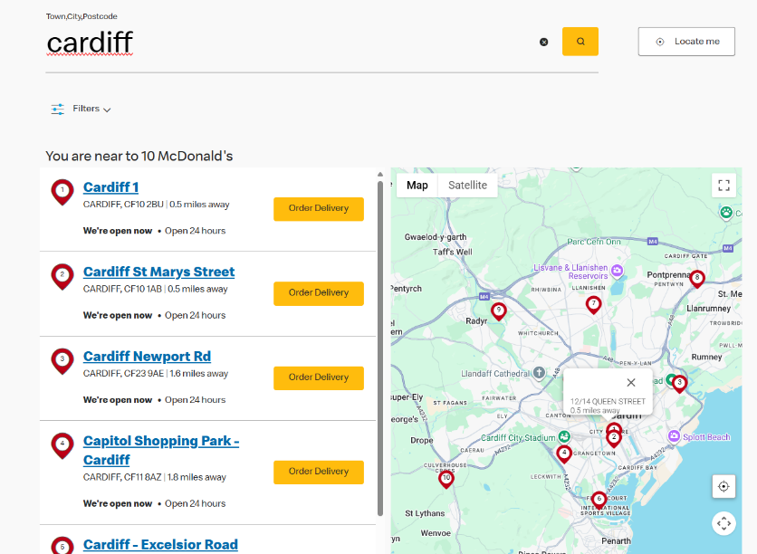
In terms of finding locations, on laptop/computer it was very easy to locate the closest McDonalds near me and the fast-food chains in my area. The website has clear subheadings and content to know which button takes you to the menu, which one takes you to delivery etc. The location finder allowed me to enter a city, town or postcode demonstrating a range of inputs and then searched for the McDonalds within my area, told me how many were nearby and then sorted these in order from closest to furthest. Alongside, this information it showed me live image of a map of the UK and allowed me to zoom in/out and navigate the map. This is very efficient and easy for customers to use, and I encountered no problems when using it. It accommodates for a wide volume of customers. If you entered an invalid location, the website would simply not respond and display the same interface as if you had entered nothing. This could be more efficient if the system would alert the customer if they had typed in an invalid or non-existent location. Displaying a message like “Location not found, please try again” could make the customer realise any spelling mistakes or issues with their input. If any spelling mistakes, but you can interpret what the input was attempting to write, they could have a “Did you mean (location name)?” message pop up to make it quicker for users to locate their closest McDonalds, rather than re-typing their whole city, town or postcode. They also have different filters to narrow down your search, making it faster to identify the exact McDonalds you’re looking for. This enhances customer experience making searching and sorting McDonalds near you a lot faster. The website was incredibly fast to load and displayed correctly on both mobile phone and computer, running smoothly.
Saray Restuarant:
Compared to McDonalds, I preferred this UX as it was more representing of the brand and more aesthetically pleasing. It showed 3 different process options such as: Reservations, Get Directions and Book Online. This platform represents the processes El Aziz would like to have in their digital system; therefore, this system is great for my inspiration. On the front page, it showed the location of the restaurant, phone number and email, presenting icons of social media platforms that would take you to the actual platform if you clicked it. It also showed the different delivery and ordering online options they used.
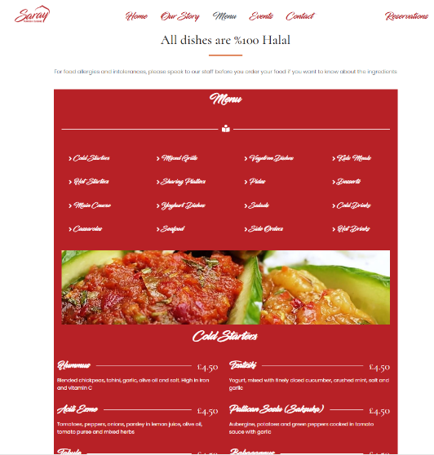
Their menu was different to McDonalds as it displayed the price and a short description of the food/cuisine. This is more user friendly, as it gives the user more information on the food and allows them to consider their purchase based off pricing. McDonalds didn't display the pricing of their food items. I’d like to incorporate McDonalds’s layout of the website, but I prefer Saray Restaurant’s menu interface as it is clear. One thing I dislike is the font choice as it isn't clear to read, whereas McDonalds was. Therefore, I would use Saray Restaurants’ layout of the menu but use a different font, like McDonalds. This menu interface is less interactive, as you only scroll down to look through the different menu items, whereas McDonalds’ had features like displaying the menu items and if you clicked on the item it would take you to the enlarged menu of the different options for that item, making it easier to customise orders. On one hand, the less instructiveness could make the interface simpler and easy to navigate, but on the other hand, it could be less user centred and make it more difficult for them in a sense. I’d like to include this feature into El Aziz’s new digital system as customers expressed dissatisfaction for the efficiency of customising orders.

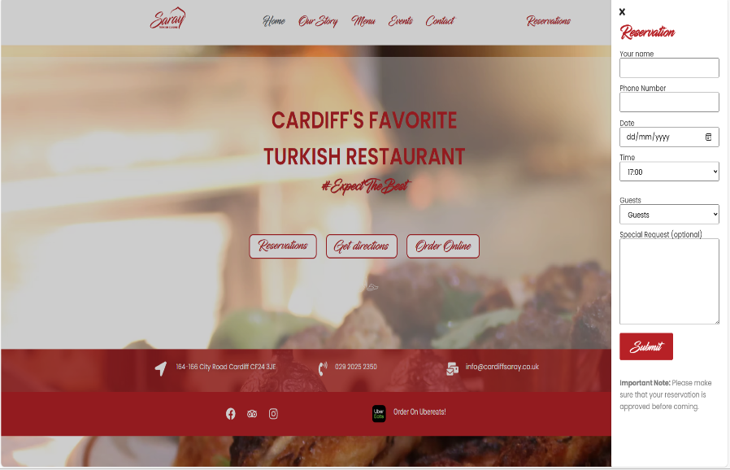
In terms of making reservations and booking tables, I really liked how clean Saray Restaurants pop up was to book a table. It asked for inputs of customers name, phone number, date and time of reservation, number of guests and even had the option for special requests. It was a small side bar pop up and was a very easy, quick and efficient process. I would like to incorporate this into my system to increase usability and efficiency.

Toast:
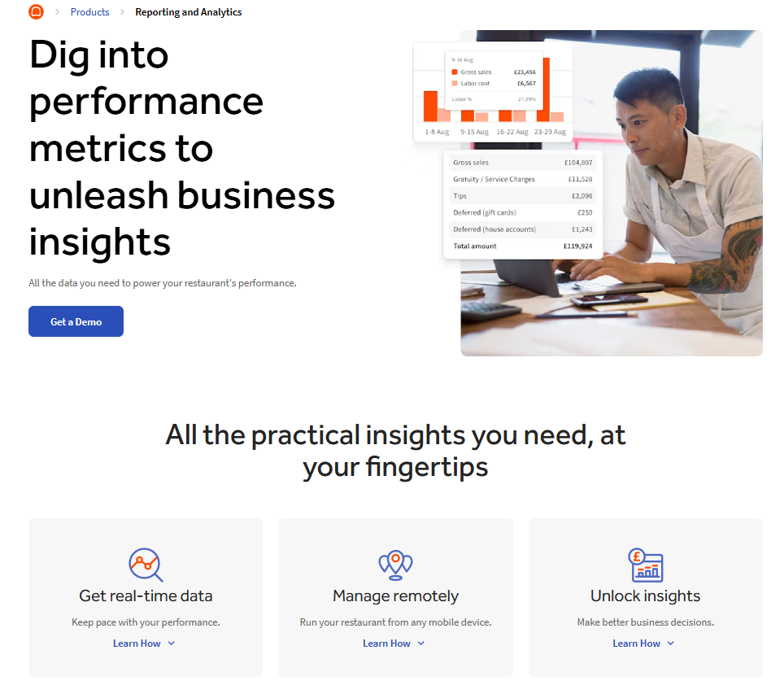
Toast is a restaurant management software I looked at to identify the way they present their reports and analytics. I would like the new El Aziz’s system to produce reports and what the most popular food item was so that they can purchase more stock ingredients to ensure they can keep producing this item and keep feeding the demand for it. This would better the reputation but also keep customers satisfied.
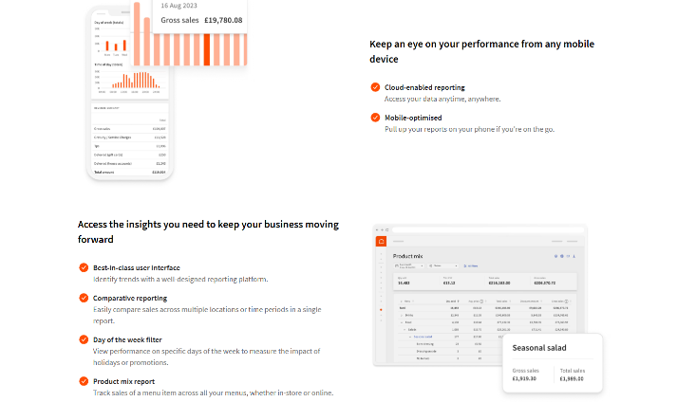
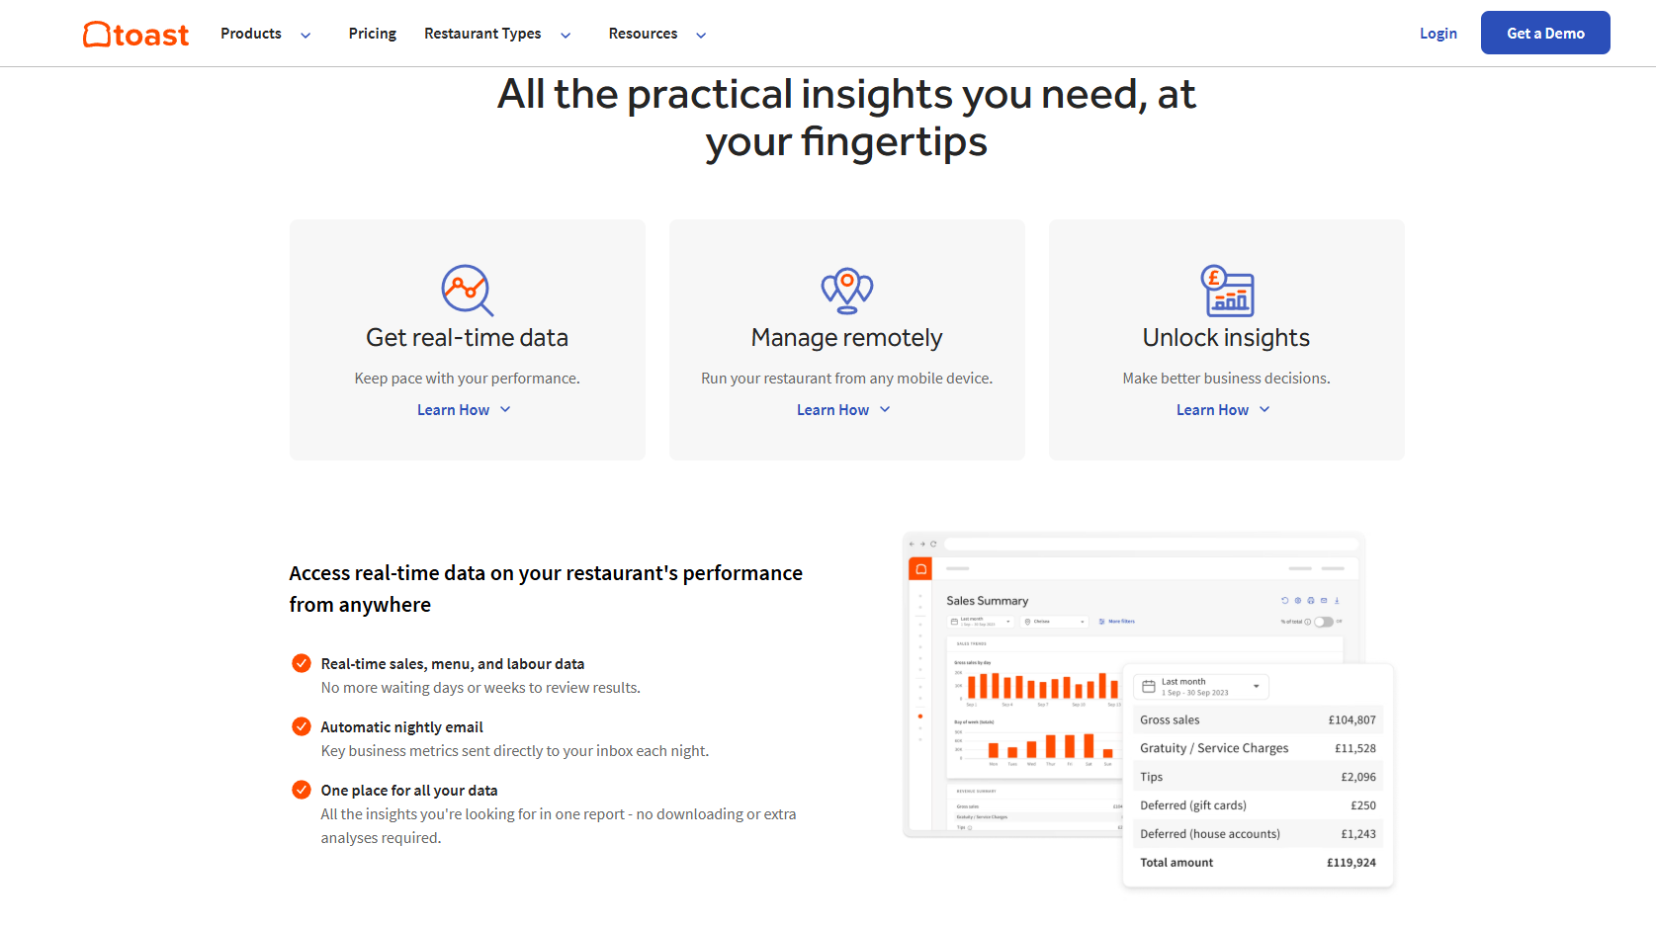
When I clicked on ’Reporting’ filter on the top bar of the website it took me to this page. I really liked the way they displayed their findings through graphs which if you hovered over, it would show you the exact number for the bar size. It also did its own calculations, showing total income, profits etc. This software allows for real time access on restaurant data which is a feature the restaurant owner expressed a want for. This reporting software allows for comparison, product mix reports and helps you identify trends quickly. Additionally, it automatically sends nightly emails to owner's inbox highlight key metrics in data. Overall, this restaurant management software is something I would like to incorporate and use in El Aziz’s new digital system as it will increase the restaurants efficiency by producing reports and data that can help improve the restaurants products and services.

STAKEHOLDERS AND USERS:
These are the groups of people that would use and interact with the newly developed systems. I also discussed how they would benefit from the features I liked from the three existing systems I analysed.
Admin:
Admins can oversee the entire system and have the authority to manage and protect data and customer information ensure it is safe. They also manage access rights, user permissions and control the settings for the platform. They have key responsibilities such as managing user accounts by either creating, changing or deleting them. They also control the different access rights between the workers and customers by assigning different roles and permissions. They manage the system monitoring tools to maintain the system and ensure regularly backups are in place and software is updated if used. They also control security measures ensuring data is protected. They would benefit from the new system including these features s it would mean they could manage user accounts and ensure customer information is kept safe and secure in a database rather than in a notebook on an open counter.

Managers:
Managers control and oversee the workers, observing workers performance and ensuring the restaurant services are executed to their standards. They also use the system for decision making and reporting. They also use analytics & reporting tools to identify key metrics such as what the most popular food item was this month. They also have the responsibility of tracking the inventory of the restaurant to identify and alert the restaurant owner when stock levels are low to ensure more stock can be ordered. Also, they handle Staff management by approving schedules, assigning shifts, monitoring performances of workers. Additionally, the view customer feedback to identify any issues/complaints, review their customer service based on customers satisfaction ratings. As well as that, they also consider the restaurants promotions and menu updates by launching offers or updating menu items quickly. Managers would benefit from such features as it would make it easier to identify when new stock is required to prevent mass shortages from occurring which could lead to disappointing customers.
Customers:
Customers will use the system to interact with the restaurant such as browsing, ordering, purchasing etc. They are simply at the restaurant to fulfil their desires. For customers, they require user-friendly UX. The digital system must be easy to navigate, displaying bright and big icons to direct the user. It must be easy to find the menu, deals and location information. It also must allow users to order online with the option to customise their order, making it more functional and user centred. Currently, El Aziz doesn’t have a variety of payment options. Therefore, customers would like to be able to pay via debit/credit card, contactless etc. Additionally, real time order tracking would be preferred so that they know when food is being prepared and can estimate and be alerted when the food will be ready. Also providing feedback is a role of customers for business to identify which areas require improvement. By allowing customers to write reviews, report issues and provide them with contact support, El Aziz can produce reports on such metrics. Customers would benefit from such features because it would enhance their experience at El Aziz, giving them a great reputation. It will also be more functional and reduce stress.
Workers:
Workers consist of chefs, waiters, cleaners, staff etc. They will complete day-to-day restaurant tasks such as taking orders, preparing food and serving customers. They communicate heavily with the kitchen, delivery staff, and customers through the system to ensure they provide quality customer services. Workers require support on using order management tools enabling them to view, update, and track incoming orders in real-time. By displaying the order queue to the customer, they can acknowledge their order waiting time and it will enhance efficiency. They also require the ability to update order status using words such as ‘ready’ or ‘preparing’ however this will be done by the new system. Moreover, workers require shift and schedule management to see assigned shifts amongst the workers/team and request any changes if wanted. Workers would benefit from such features because it would reduce the workload on them, reduce stress and making their jobs more convenient and easier. It would also reduce the number of incorrect orders, payment errors etc.

ANALYSIS AND LIMITATIONS:

The existing system that matched most of my expectations and vision for my El Aziz digital system was Saray Restaurant’s. Therefore, I created a Data Flow Diagram visualising the current input, processes and outputs they have, and to understand their systems data flow. This will help me understand how El Aziz’s system should operate but with extra features.

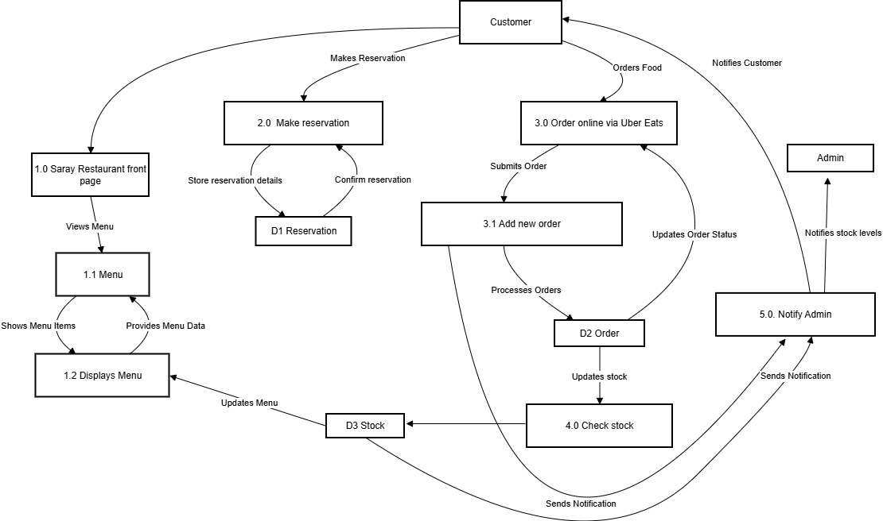
Current system:

Main Inputs, Processes and Outputs:
Ultimately, Saray restaurant shares the same inputs, processes and outputs as El Aziz as they are both restaurants executing the same tasks and processes to function.
However, El Aziz is paper based whereas Saray is computerised.

The main inputs of Saray’s system include reservation details, adding new customer details and order details. These inputs are necessary in order to carry out regular procedures a restaurant should. Customer inputs consist of personal details such as name, email and phone number. They also input booking details like the date, time and the number of people for the reservation. In terms of order details, they input menu items, the quantity and any special customisations. For staff and admin, they have no inputs on Saray’s website. To gather inputs and information, Saray uses forms to collect information, whereas El Aziz does this manually by writing information down on paper.
The main processes of Saray Restaurant are checking availability by looking at the reservations database. They also execute calculations. When ordering online through Uber eats, as you select your items and specify the quantity and any special customisation or additional sides, the customer’s total id automatically calculated in real-time so they can see the cost. Uber eats also automatically stores the customer’s information so that it can be delivered to the customer's house. If it is getting picked up, they send the information to Saray to confirm the order is collected by the right customer. Contrastingly, El Aziz manually calculates their orders using an old calculator but most of time staff do it in their head. Checking availability, storing and deleting data is done manually by looking through the notebook to find the data.
The main outputs for Saray Restaurant for customers are a displayed menu, booking confirmation through message or email, order receipt, payment confirmation, notifications on order via messages and phone calls, booking status and feedback submission. The outputs of messages and phone are sent to the customers phone number, so it is digital. The customer’s receipt and order status is displayed on the screen, and their receipt is sent to their email. When you collect your food there is a piece of paper with the order number, customer name and summary written on the note which is stuck in the bag. Different to El Aziz, no receipts are printed out however they do generate invoice through messages and phone calls to customers phone numbers. Most of their orders by customers are made in real time at the restaurant, so delivering food to home is not common.
Current Limitations of Saray Restaurant:
- Reservation:
- On the contact / reservation page it says, “Important Note: Please make sure that your reservation is approved before coming.” However, it isn’t clear on how the approval process works. It raises questions like does the user get a confirmation, how fast, etc. This can cause confusion and can create a poor user experience.
- Ordering online:
- When you go to order online it takes you to UberEats which is a different online ordering system, suggesting that the site does not have its own built-in ordering system. It also only allows you to order as if it were to be delivered to your house, or you can order food and then pick it up from the restaurant. This shows how it doesn’t let you order in real-time at the restaurant and dine in. This limits user experience and ultimately results in longer waiting and ordering times. This limits flexibility and can cause delay in order confirmation.
- Minimal User Interactivity:
- On the website, the restaurant allows you to make reservations, order online and see contact information. There is no user login, account system, loyalty system or order tracking visible from what I saw. This limits its functionality and user experience as it isn’t user interactive. Due to no account system, it can also raise concerns for data security when making reservations.

Current Limitations of El Aziz:
To outline the problems found from this investigation, the current paper based manual system is inefficient because:

- Customer orders and bookings are easily lost:
- Due to the orders and reservations being taken via paper and pen, the paper can easily be damaged or lost. This shows the High risk of human error. There is no organisation of the data. My interview with El Aziz’s owner, Sherzod Karimov, explained their current system, demonstrating how orders are written on little notepads and then taken to staff. The lack of security and storage for the orders and bookings limits El Aziz’s functionality and performance. When this information is lost, it can cause frustration and concern for the customers, resulting in poor user experience.

- Staff’s workload is intense and they are overwhelmed:
- Another limitation of their current system is that with the use of notepads, comes the stress and pressure of accuracy. When the restaurant is busy, it’s difficult for a waiter to get every single order of the tables they take correct. They also must go from the table to the kitchen to deliver the order to them, which is inefficient and time consuming. From my observation, I saw the use of notepads, flicking through pages made them stressed as they desperately tied to find the information.

- Data is not kept secure and safe:
- In my interview with Sherzod, data organisation and security were described as one of the biggest and the main issue for the current paper based manual system at El Aziz. All information on customers for reservation, orders, stock, staff information etc. is written inside categorised notebooks that are kept on the counter at the front desk. This is dangerous as the data isn’t kept secure and can easily be damaged, lost or stolen. It also can cause concern in customers to see how their data is handled. It is also difficult to maintain and update the data, reducing its efficiency.

Aims:
In order for their new digital system to be successful, I aim to:
- Display the customer menu in a user-friendly way.
- Allow easy and simple navigation of the platform
- Allow for efficient creation of orders and bookings of reservations
- Allow customers to edit and customise their orders
- Store data on orders and booking securely
- Allow easy access to orders and reservations booked
- Work efficiently and easily
- Be able to generate analytics and reports on the restaurant
- Allow customer to share feedback via feedback forms after visiting

Justification of Proposed Solution:
My proposed solution for El Aziz’s digital system will mainly use python as the programming language, TKinter for the graphical user interface and SQLite for the databases. I have chosen to use this combination because it can provide functionality, efficiency and achieve high performance. It will also make the development of this program easier and quicker.
I have chosen to use Python as it is my stronger point of programming. I am comfortable and have experience writing code in python, therefore using it now won’t be an issue. I believe python is extremely easy to navigate and write, with clear syntax warnings, it makes it a lot easier to write complex systems like this restaurant. It is ideal for fast development because of its simple syntax that is readable, making it easy to write and maintain. It is also well known for its reliability and variety of libraries, which will allow me to embed additional functionality such as data validation, encryption for user accounts, login features and report generation. Python provides a range of data structures for efficient data storage, making it easy to manage data such as customer information, orders and reservations. It also allows errors to be managed effectively due to its strong exception handling, preventing the system from crashing and training it to handle unexpected inputs. Ultimately, Python’s error handling improves user experience and reliability which aligns with the aims of my proposal. This makes it ideal for building a system that requires both security and flexibility, like El Aziz.
The graphical interface will be developed using Tkinter, which is included in Python’s standard library. This framework allows for the creation of a simple, effective and smooth graphical user interface that is suitable for users with little technical experience, like me. It runs efficiently and loads quickly which is supportive of my proposal. Despite having no experience in TKinter, I decided to create a graphical user interface because in my interview with Sherzod, he expressed how it would be nice to have easy booking table management, a nice display of the menu and an interactive system. He wanted it to be aesthetically pleasing to engage with customers. Therefore, creating a GUI would be more suitable than a CLI as this can support buttons, forms, and icons, making it easy for users to log in, make reservations, create orders, and track them. I intend to learn TKinter before development to ensure I can import it correctly and develop a reliable and functional GUI. Since the restaurant system will be used by both staff and customers, a clear GUI with buttons, icons, and forms is essential for ease of use and accessibility. Tkinter also supports event-driven programming, meaning user button clicks can trigger actions like adding orders, creating reservations, or logging in. This makes the application more responsive and closely aligned with El Aziz’s system requirements. Ultimately, it provides an intuitive and responsive environment that enhances user experience and reduces the chance of human error. It is also portable meaning it can run on different operating systems, making it flexible and easy to deploy.
The system will use SQLite for data storage and management as it is reliable and efficient, allowing for fast data retrieval when handling tasks such as booking reservations, saving orders, or tracking payments. SQL also works well with Python, therefore using them together ensures the system can handle data reliably. This is ideal for El Aziz as Sherzod (owner of El Aziz) expressed that the biggest issue was data handling and security. Using SQL will benefit the customers, staff and admin as data will be stored safely, can be accessed whenever and quickly. This will reduce the workload and pressure on staff to remember the orders and deliver to the kitchen staff. Using SQL means kitchen staff will automatically be sent the orders and can access the database to see more. Moreover, using SQL databases ensure data can be organised and maintained. When information is incorrect and needs to be updated or new information needs to be added, it makes it a lot easier to do so in a database rather than writing it to a python text file. I recently learnt SQL basics, which is enough to incorporate into this system.
In conclusion, using Python, Tkinter, and SQLite is suitable for El Aziz because it ensures that the system is efficient, secure, and portable. Overall, this setup allows the restaurant system to meet user needs effectively, providing an efficient, user friendly and reliable solution.
SPECIFICATION AND OBJECTIVES:
Specification:
EL Aziz have asked me to develop a digital system that:
- Displays an interactive menu
- Allows customers/users to create and login to their accounts
- Allows customers to create orders
- Allows customers to customise orders
- Allows customers to book reservations
- Allows customers to provide feedback
- Generates reports or metrics on restaurant
- Is an intuitive and functional system, satisfying customers.
Objectives:
- User Account Management
- Customers can create new accounts with secure username and password storage.
- Customers, staff and admin can log in and out of their account.
- Stakeholders can update their personal details (e.g., name, phone number, email).
- Accounts are saved and retrieved correctly from the SQL database.
- Admin should be able to create, change and delete all accounts. They should be able to retrieve staff and customer information. They should also receive the reports and metrics on the restaurants profit. They also can update the menu, on the availability prices and ingredients.
2. Interactive Menu Display
- The system will display an interactive and categorised restaurant menu, organised into starters, mains, desserts and drinks.
- Users can view item details such as description, any allergens, price, and availability.
- Menu data loads correctly from the SQL database and updates when items are changed or added by staff.
3. Order Creation and Customisation
- Customers can select menu items to add to an order and customise them (e.g., size, toppings and special requests).
- Orders can be edited or cancelled before confirmation.
- Orders are correctly stored in the SQL database, linked to the customer’s account, and displayed in a summary screen.
- To calculate the total of the order an algorithm that can link the costs of their reservation, order and possibly a tip must be implemented. This should be outputted through a receipt.
4. Reservation Management
- Customers can make, view, edit, or cancel table reservations.
- System prevents double-booking by checking table availability in real-time.
- Reservation data is validated and stored accurately in an SQL reservation database, ensuring no overlap in booking times.
5. Feedback Collection
- Customers can submit feedback through a simple form after placing an order or visiting the restaurant.
- Feedback includes ratings (1–5) and optional comments.
- Feedback entries are correctly saved in the SQL database and retrievable for reporting.
6. Report Generation
- Staff can generate reports on sales, most popular items, reservation trends, and feedback summaries.
- Reports are displayed in the GUI and can be exported (e.g., text file)
- Reports display accurate, up-to-date data from the SQL database.
7. Data Backup and Security
- All data (accounts, orders, reservations, and feedback) is stored securely in the SQL database and backed up externally.
- Passwords are stored using encryption.
- Validation is put in place for login.
- Backup files can be created and restored successfully
8. User Experience of System
- The GUI will use a consistent and accessible colour scheme suitable for all users.
- UX should represent the restaurant through colour schemes, logos and images.
- When the system is loaded, they should be shown a GUI which asks for their login. Depending on their access level, they will be shown different options.
- Navigation will be intuitive, with clear button labels and prompts.
- UX design will be inclusive and consider those with disabilities or special needs.
9. Stakeholders:
- Admin should be able to create, change and delete all accounts. They should be able to retrieve staff and customer information. They should also receive the reports and metrics on the restaurants profit, as well as notifications and data on stock levels. They also can update the menu, on the availability prices and ingredients.
- Customers should be able to create and edit an account. They should be able to request that their order or reservation be cancelled or rescheduled. They should be able to create, customise and edit an order before purchasing. They should receive confirmation of their order and reservation via invoice.
- Staff should be able to create, edit and delete their account. In terms of waiters and waitresses, they should be able to retrieve customer orders and the customer’s information to deliver it to the correct customer. They should also be notified when a table needs assistance. They should also be able to access the reservation database to set up in advance. Chefs should be able to access the database on customer orders to cook the correct meal and the statistics on how many customers they currently have and are expecting. Staff, chefs and cleaners should be allowed to access their work shift through their account. Cleaners should have access to see which reservations are in use.
Desired performance:
To deem this system successful, I expect the program to be able to load quickly and successfully, displaying a colourful and representing GUI for El Aziz. It should display their logo and images for aesthetics. It should prompt all stakeholders to log in or create an account. When logging in, there should be validation in place to prevent unauthorised access. If they choose to create an account, they should be able to fill out the fields on their information, creating a secure username and password before logging in. Depending on the role of being a customer, staff or admin, different options will be displayed.
For the customers, they will be displayed a menu to create an order, make a reservation and provide feedback. They should be able to easily navigate the system with clear instructions on what to do. When making a reservation, they should be prompted to fill out a form to input data like number of people, email, date and time etc. They will be sent a confirmation of their reservation via email and message. When creating an order, customers should be able to select the item and customise it. This should be added to a cart with the total being automatically calculated and shown. Customers should then be able to make a payment. They will be sent an order confirmation via email and message. They will be allocated an order number and be shown the estimated waiting time. Once complete food will be served at their table. When providing feedback, they should be able to fill out the form to gather the information.
For staff in terms of waiters, waitresses and chefs, they should be able to view their shifts by looking at their account. Here, it should show a table on their shifts. They should also be able to see who is currently working. Waiters and waitresses should be able to be notified when an order is complete to get from the kitchen and serve to the customers. Chefs should be able to access the stock levels database to notify when new stock should be ordered. They should be able to see the order and reservation database to be prepared in advance. Cleaners should be able to see their shifts by viewing their account and only have access to the reservation database to see which table needs cleaning. For each of the stakeholder’s access rights, they should be able to view the databases through their account.
Admins will be promoted with options to edit the menu, order stock, and view all information of staff and customers. They should also be able to view all pending orders and reservations. They should also have the option to generate and view reports/ analytics to improve the restaurant. After any of the stakeholders have performed an option, they should automatically be sent back to their menu of options depending on their role and access rights.
Overall, the system should run flawlessly and efficiently, ensuring no human error weakens the customer experience. The systems success can be measured by customer experience and their feedback through reviews. I believe this proposal is suitable and will benefit El Aziz. However, I do understand and acknowledge that I may not be able to develop the system to execute each and every objective perfectly.

